Student Name: Harrison Cole, 10632167
Module/Function Name: “NaughtsAndCrosses”
File Name: “Mobile Application Assignment”
Lines of code (LOC) are excluding indents, notes, and empty lines. Some info may be inaccurate, account for +-5 lines of error.
Timing may be slightly inaccurate due to undocumented mini-breaks and research time. Time will be generally accurate with a degree of error of ~20 minutes in some cases.
Some of the code shown in the explanation section may not match up to the LOC column in the table. This is due to some changes being within existing lines of code. As well as this, some code in the explanation is for context so that it gives an idea on how it was implemented.
 | Start Date and Time | Stop Date and Time | Time Taken | LOC
1 | 24/08, 12:32pm | 24/08, 1:05pm | 33 minutes | 40 lines of code total
2 | 24/08, 1:10pm | 24/08, 1:30pm | 20 minutes | 46 lines of code total  Worked on 6 lines of code
3 | 25/08, 4:30pm | 25/08,  6:42pm | 132 minutes  1 hour 12 minutes | 60 lines of code total  Worked on 25 lines of code
4 | 25/08, 8:28pm | 25/08, 8:40pm | 12 minutes | 62 lines of code
5 | 1/09,  10:50am | 1/09,  12:00pm | 70 minutes  1 hour 10 minutes | Net 0 lines
6 | 8/09,  1:30pm | 8/09,  3:50pm | 140 minutes  2 hours 10 minutes | 132 lines of code total  Worked on 70 lines of code
7 | 11/09,  11:10am | 11/09,  11:35 | 25 minutes | 138 lines of code total  Worked on 6 lines of code
8 | 12/09,  2:35pm | 12/09,  2:40pm | 5 minutes | 157 lines of code total  Worked on 21 lines of code
9 | 12/09,  7:30pm | 12/09,  7:45pm | 15 minutes | 182 lines of code total  Worked on 25 lines of code
10 | 12/09,  7:50pm | 12/09,  8:20pm | 30 minutes | 190 lines of code total  Worked on 17 lines of code
11 | 19/09,  9:30am | 19/09,  9:50am | 20 minutes | 208 lines of code total  Worked on 18 lines of code
12 | 19/09,  1:00pm | 10/09,  2:25pm | 85 minutes  1 hour 25 minutes | 277 lines of code total  Worked on 69 lines of code
13 | 26/09,  3:00pm | 26/09,  3:45pm | 45 minutes | 290 lines of code total  Worked on 13 lines of code
14 | 27/09,  11:25am | 27/09,  12:10pm | 45 minutes | 322 lines of code total  Worked on 32 lines of code
15 | 27/09,  3:00pm | 27/09,  3:35pm | 35 minutes | 347 lines of code total  Worked on 25 lines of code
16 | 27/09,  7:00pm | 27/09,  7:55pm | 55 minutes | 413 lines of code total  Worked on 63 lines of code
17 | 28/09,  2:30pm | 28/09,  4:55pm | 145 minutes  2 hours 25 minutes | 457 lines of code total  Worked on 44 lines of code
18 | 28/09,  7:00pm | 28/09,  7:50pm | 50 minutes | 467 lines of code total  Worked on 10 lines of code
19 | 29/09,  8:45am | 29/09,  10:00am | 75 minutes  1 hour 15 minutes | 547 lines of code total  Worked on 80 lines of code
20 | 29/09,  6:40pm | 29/09,  8:25pm | 105 minutes  1 hour 45 minutes | 591 lines of code total  Worked on 44 lines of code
21 | 29/09,  8:30pm | 29/09,  8:55pm | 25 minutes | 603 lines of code total  Worked on 12 lines of code
22 | 29/09,  9:10pm | 29/09,  9:50pm | 40 minutes | 611 lines of code total  Worked on 8 lines of code
23 | 30/9,  9:40am | 30/09,  10:00am | 20 minutes | No code changed

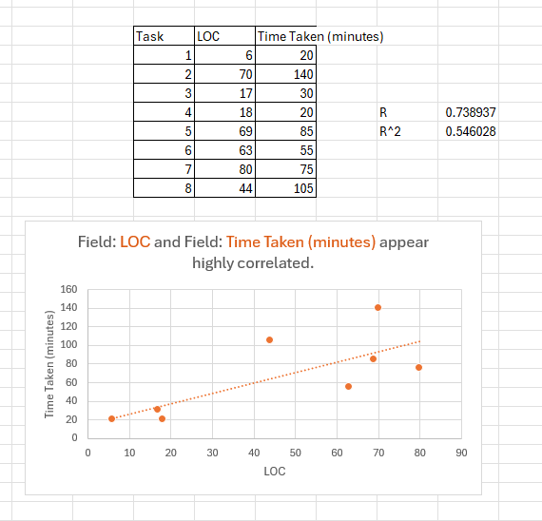
Measurements:

The data points I used in the time log are as follows: 2, 6, 10, 11, 12, 16, 19, and 20. I used these points as I believed it showed the greatest change of behaviour when writing the code.
The graph shows what everyone knew, being that the more lines of code you write, the longer it takes generally. There are 2 outlying points skewing the data positively, those being point 8 and point 5. Without these in the data we can assume that the line R (the correlation, 0.74) would be skewed slightly more negatively, showing at least some improvement over time. You get this number by finding the standard deviation between the X and Y variables and then using that to divide the covariance. With only 8 points of data, it is hard to definitively say that any improvement was made, even though, biased as I may be, I feel as though I have improved in my lua coding in both accuracy and efficiency tenfold.
The regression calculation for R² (0.55) indicates that the data is not as dependent on each other as one would like. A higher number indicates that there is less possibility for outside influence, as in one data point directly influences the other.
Code change descriptions and actual code BLACKBOX TESTING:
- Using and understanding assignment code snippets (changing colours and changing parameters to understand what parts did what, ultimately no permanent changes made)
d = display
w20 = d.contentWidth * .2
h20 = d.contentHeight * .2
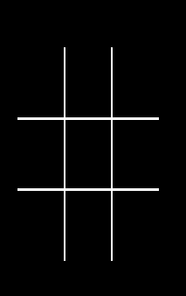
w40 = d.contentWidth * .4
h40 = d.contentHeight * .4
w60 = d.contentWidth * .6
h60 = d.contentHeight * .6
w80 = d.contentWidth * .8
h80 = d.contentHeight * .8

----DRAW LINES FOR BOARD
local lline = d.newLine(w40,h20,w40,h80 )

lline.strokeWidth = 5

local rline = d.newLine(w60,h20,w60,h80 )
rline.strokeWidth = 5

local bline = d.newLine(w20,h40,w80,h40 )
bline.strokeWidth = 5

local tline = d.newLine(w20,h60,w80,h60 )
tline.strokeWidth = 5 (recreated due to missing screenshot)

--PLACE BOARD COMPARTMENT DIMENSIONS IN TABLE
board ={

{"tl", 1, w20, h40, w40, h20,0},
{"tm",2, w40,h40,w60,h20,0},
{"tr",3, w60,h40,w80,h20,0},

{"ml", 4, w20, h60, w40, h40,0},
{"mm",5, w40,h60,w60,h40,0},
{"mr",6, w60,h60,w80,h40,0},

{"bl", 7, w20, h80, w40, h60,0},
{"bm",8, w40,h80,w60,h60,0},
{"br",9, w60,h80,w80,h60,0}
}

--FILL COMPARTMENT W/ COLOUR WHEN TOUCHED
local function fill (event)
if event.phase == "began" then
tap = 0
for t = 1, 9 do
if event.x > board[t][3] and event.x < board [t][5] then
if event.y < board[t][4] and event.y > board[t][6] then
if board[t][7] == EMPTY then
board[t][7] = whichTurn
whichTurn = whichTurn == X and O or X
end
end
end
end
end

end
Runtime:addEventListener("touch", fill)

- Changing the grid to display a circle when clicked instead of a filled in rectangle, and changing the circle to be a line instead of filled. Most of the time spent tweaking the circle position to try and centre it and
if whichTurn == O then
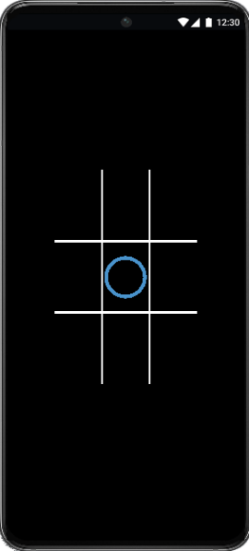
--Create circle and place it in the specified location
r = d.newCircle(board[t][3] + 3, board[t][6] + 20, w20 / 2.5, h20 / 2.5)
r:setFillColor(0, 0, 0, 0)
r:setStrokeColor(0.29, 0.58, 0.80)
r.strokeWidth = 5
r.anchorX = 0
r.anchorY = 0

- Creating an ‘X’ and formatting it (changing colours, tweaking shape, and moving it into a central position in the grid), as well as making the naughts and crosses alternate
local EMPTY, X, O = 0, 1, 2
local whichTurn = O

if whichTurn == O then
--Create circle and place it in the specified location
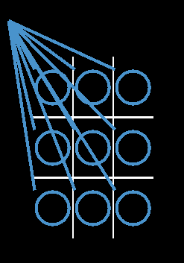
r = d.newCircle(board[t][3] + 3, board[t][6] + 20, w20 / 2.5, h20 / 2.5)
r:setFillColor(0, 0, 0, 0)
r:setStrokeColor(0.29, 0.58, 0.80)
r.strokeWidth = 5
r.anchorX = 0
r.anchorY = 0
else
--Create cross and place it in the specified location
local centerX = (board[t][3] + board[t][5]) / 2
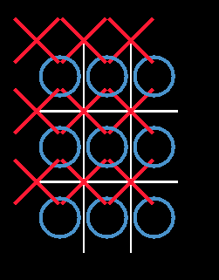
local centerY = (board[t][4] + board[t][6]) / 2
local size = 30
r = d.newLine(centerX - 20, centerY - size, centerX + 20, centerY + size)
r:setStrokeColor(1, 0.1, 0.2)
r.strokeWidth = 5
r.anchorX = 0
r.anchorY = 0
r = d.newLine(centerX - 20, centerY + size, centerX + 20, centerY - size)
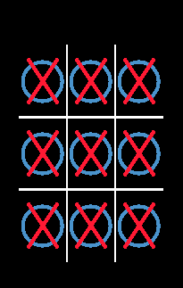
r:setStrokeColor(1, 0.1, 0.2)
r.strokeWidth = 5
r.anchorX = 0
r.anchorY = 0
end
--alternate turns
whichTurn = whichTurn == X and O or X
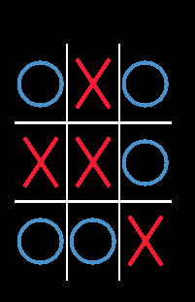
end

- Printing which turn and which space was clicked to the console
Print (“O plays in space”, t)
…
Print("X plays in space", t)
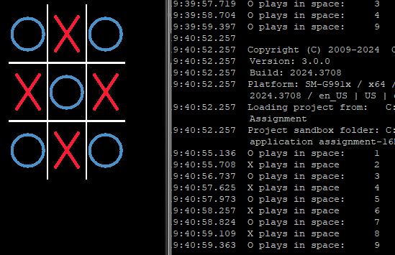

- Attempting to create a start screen. After 70 minutes of failed programming, I decided to set myself back to where I was at the end of part 4.

- First chunk of time spent trying to create a button that would disappear and start the game when clicked, however after running into a number of challenges, I decided to create a faux button, that does everything specified, without actually being a button. Subject to change at a later date.

Next chunk of time was spacing the titles on the screen and fiddling with different themes. What is seen currently is a bare-bones look as the vanity will come later.

local widget = require("widget")

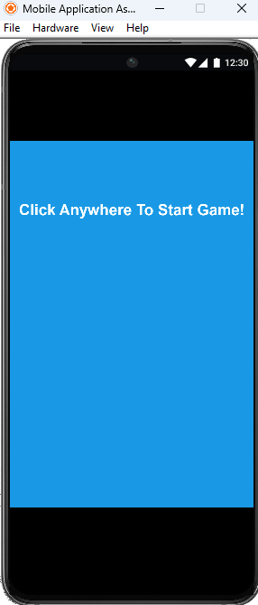
local centerX = d.contentCenterX
local centerY = d.contentCenterY
local screenLeft = d.screenOriginX
local screenWidth = d.contentWidth - screenLeft * 2
local screenRight = screenLeft + screenWidth
local screenTop = d.screenOriginY
local screenHeight = d.contentHeight - screenTop * 2
local screenBottom = screenTop + screenHeight
local screenTopSB = screenTop + d.topStatusBarContentHeight
local screenHeightSB = d.contentHeight - screenTopSB
local screenBottomSB = screenTopSB + screenHeightSB

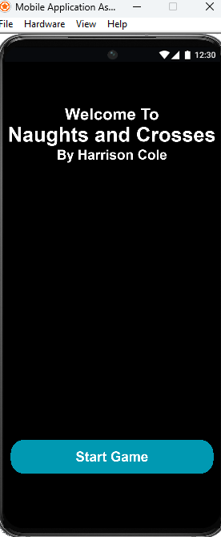
-- move sections off screen
local function offScreen(object)
object.x = -object.width
object.y = -object.height
end

local titleScreen = d.newText({
text = "Welcome To",
x = d.contentCenterX,
y = screenTop + 100,
font = native.systemFontBold,
fontSize = 24
})
titleScreen:setFillColor(1, 1, 1, 1)

local titleScreen2 = d.newText({
text = "Naughts and Crosses",
x = d.contentCenterX,
y = screenTop + 130,
font = native.systemFontBold,
fontSize = 30
})
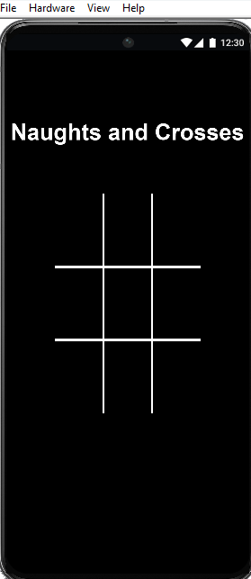
titleScreen2:setFillColor(1, 1, 1, 1)

local titleScreen3 = d.newText({
text = "By Harrison Cole",
x = d.contentCenterX,
y = screenTop + 160,
font = native.systemFontBold,
fontSize = 20
})
titleScreen3:setFillColor(1, 1, 1, 1)

local roundedRect = d.newRoundedRect(
d.contentCenterX,
d.contentCenterY + 250,
300,
50,
20
)
roundedRect:setFillColor(0, 0.6, 0.7)

local startGame = d.newText({
text = "Start Game",
x = d.contentCenterX,
y = d.contentCenterY + 250,
font = native.systemFontBold,
fontSize = 20,
labelColor = { default={1, 1, 1, 1}, over={1, 1, 1, 1} }
})

…

if event.phase == "began" then

offScreen(titleScreen)
titleScreen2:setFillColor(1,1,1,1)
offScreen(titleScreen3)
offScreen(startGame)
offScreen(roundedRect)

- Time spent creating a custom background through adobe illustrator and then displaying that background as a certain transparency. Complete vanity work.

local background = d.newImage( "bground2.png" )
background.width = screenWidth
background.height = screenHeight
background.x = centerX
background.y = centerY
background.alpha = 0.4

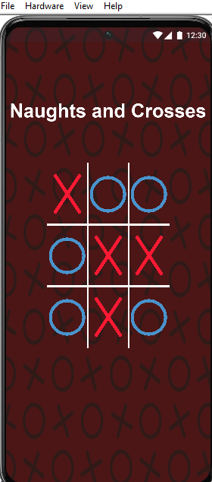
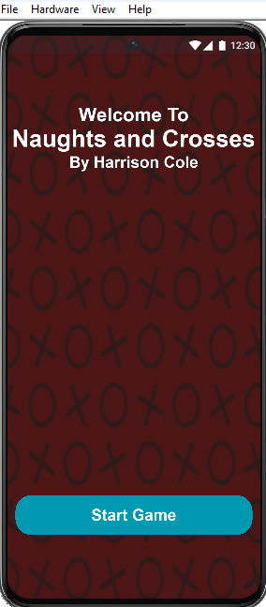
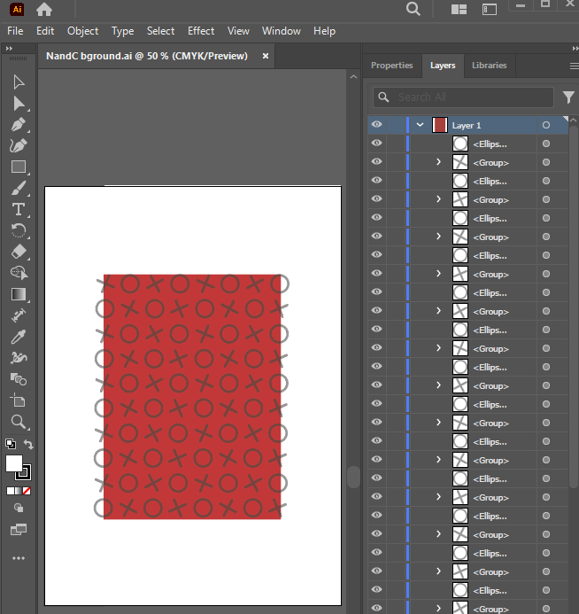

- Tweaked the console output of the board space to actually say the position and number, instead of just number

if t == 1 then
bspace = "Top Left Square"
elseif t==2 then
bspace = "Top Middle Square"
elseif t==3 then
bspace = "Top Right Square"
elseif t==4 then
bspace = "Middle Left Square"
elseif t==5 then
bspace = "Middle Square"
elseif t==6 then
bspace = "Middle Right Square"
elseif t==7 then
bspace = "Bottom Left Square"
elseif t==8 then
bspace = "Bottom Middle Square"
elseif t==9 then
bspace = "Bottom Right Square"
end
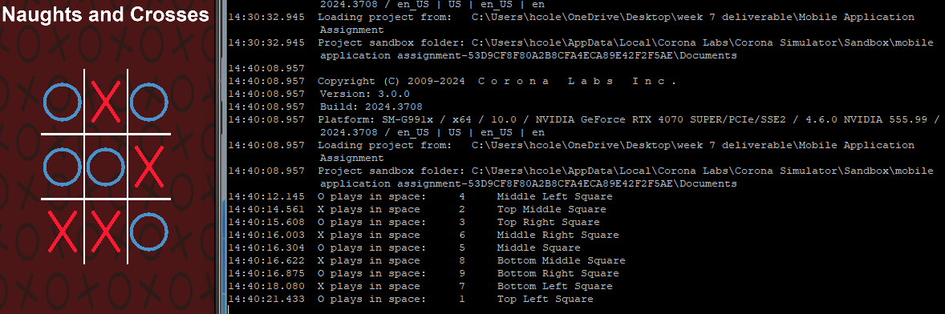

- This session was spent creating the win condition for the game, as in when O for example plays in all spaces 1 2 and 3, stop the game and display that they have won

local WinCon = {
{1, 2, 3},
{4, 5, 6},
{7, 8, 9},
{1, 4, 7},
{2, 5, 8},
{3, 6, 9},
{1, 5, 9},
{3, 5, 7}
}

local function Winner()
for i = 1, #WinCon do
local combo = WinCon[i]
if board[combo[1]][7] == whichTurn and
board[combo[2]][7] == whichTurn and
board[combo[3]][7] == whichTurn then
return true
end
end
return false
end

if Winner() then
print("Player”, whichTurn, “is the Winner!!!")
Runtime:removeEventListener("touch", NaughtsAndCrosses)
else
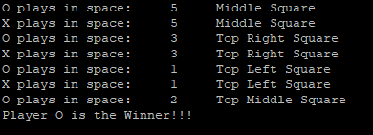

- This time was spent making the computer ‘easy’ mode for the program, which meant taking away the ability to play as ‘X’ and randomising it. Some problems I ran into included having to still click after playing as ‘O’ for the computer to take a space. This would also result in playing ‘phantom’ Xs, as in placing invisible Xs before the computers turn and locking that board space. I fixed this by removing the initial whichTurn switcher and manually switching the turn after each play.
Unintentionally perfect, changing the name from ‘X’ to ‘Computer’ in the console displayed all of the moves by the player, ‘O’ on the left side, and all random moves on the right side, creating a visual divide between the player and computer.

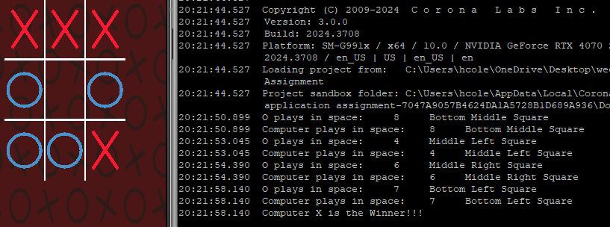

- Making the Button for activating hard mode on the starting screen and setting up the logic for when the button is pressed (for starters, printing ‘hard mode activated’). The button is linked to a boolean variable ‘isHardMode’ which is false by default and switches to 2 when pressed
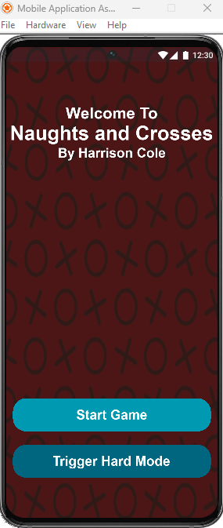

local hardmode = d.newRoundedRect(
d.contentCenterX,
d.contentCenterY + 275,
300,
50,
20
)
hardmode:setFillColor(0, 0.4, 0.5)

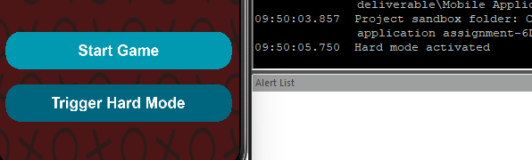
local function startHard(event)
if ( "began" == event.phase ) then
isHardMode = true
print("Hard mode activated")
end
end

local hardButton = widget.newButton({
label = 'Trigger Hard Mode',
id = "onEvent",
x = d.contentCenterX,
y = d.contentCenterY + 275,
width = 278,
height = 32,
font = native.systemFontBold,
fontSize = 20,
labelColor = { default={1, 1, 1, 1}, over={1, 1, 1, 1} },
onEvent = startHard
})

- This section of time was spent creating the actual logic for what hard mode is. This involved the computer determining the best place to play instead of picking a random spot. Firstly, the computer will check to see if the centre square is empty, and if it is, this will always be its first move. It will then look towards the corners to do the exact same thing. As soon as the computer has 2 in a row it will try and get the winning spot. Throughout all of this it should check whether the player is close to a win, and attempt to block the player off. You will see in the code the double-up of logic within the game function, this will be fixed at a later date. As soon as I got the first part of this logic done, the rest was pretty straightforward, however issues arose in the implementation stage, as I kept running into the issue of ‘easy mode’ working, but ‘hardmode’ would cause an error or X wouldn’t play. Turns out, after 30 minutes of debugging, I discovered I had named the hardmode logic ‘hardmode’ which if you look at the previous segment, the button is also called ‘hardmode’. The feeling of this discovery cannot be described in any way other than misery.

local function playhard()
-- find winning move for X
for i = 1, #WinCon do
local combo = WinCon[i]
if board[combo[1]][7] == X and board[combo[2]][7] == X and board[combo[3]][7] == EMPTY then
return combo[3]
elseif board[combo[1]][7] == X and board[combo[3]][7] == X and board[combo[2]][7] == EMPTY then
return combo[2]
elseif board[combo[2]][7] == X and board[combo[3]][7] == X and board[combo[1]][7] == EMPTY then
return combo[1]
end
end
-- block human player
for i = 1, #WinCon do
local combo = WinCon[i]
if board[combo[1]][7] == O and board[combo[2]][7] == O and board[combo[3]][7] == EMPTY then
return combo[3]
elseif board[combo[1]][7] == O and board[combo[3]][7] == O and board[combo[2]][7] == EMPTY then
return combo[2]
elseif board[combo[2]][7] == O and board[combo[3]][7] == O and board[combo[1]][7] == EMPTY then
return combo[1]
end
end
-- pick the center square if available
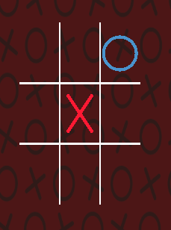
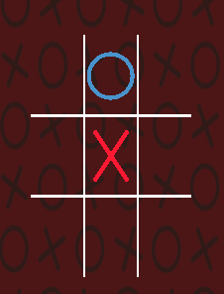
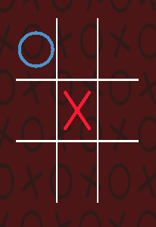
if board[5][7] == EMPTY then
return 5
end
-- pick a corner if no center
local corner = {1, 3, 7, 9}
for i = 1, #corner do
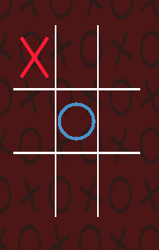
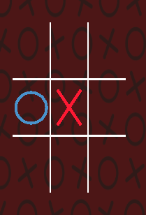
if board[corner[i]][7] == EMPTY then
return corner[i]
end
end
-- otherwise pick an edge
local edge = {2, 4, 6, 8}
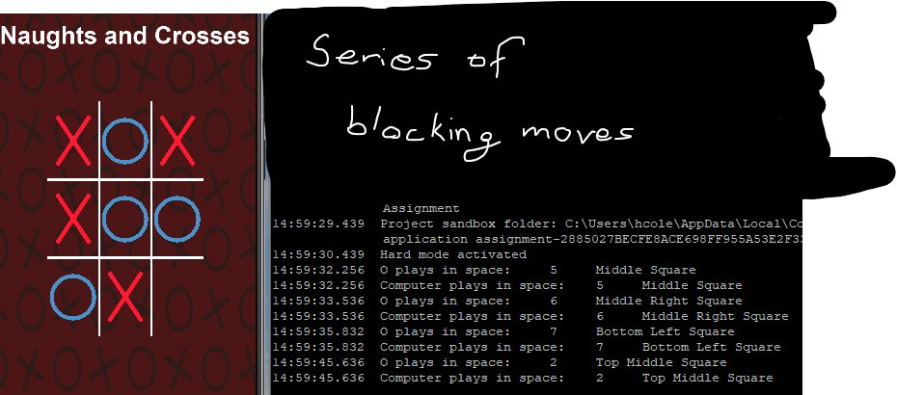
for i = 1, #edge do
if board[edge[i]][7] == EMPTY then
return edge[i]
end
end
-- no moves left
return nil
end

if not isHardMode then --its not in hard mode

local playableSpace = {}
for i = 1, 9 do
if board[i][7] == EMPTY then
table.insert(playableSpace, i)
end
end

if #playableSpace > 0 then
local randomiser = math.random(#playableSpace)
local compChoice = playableSpace[randomiser]
board[compChoice][7] = X

--Create cross and place it in random location
local centerX = (board[compChoice][3] + board[compChoice][5]) / 2
local centerY = (board[compChoice][4] + board[compChoice][6]) / 2
local size = 30

r = d.newLine(centerX - 20, centerY - size, centerX + 20, centerY + size)
r:setStrokeColor(1, 0.1, 0.2)
r.strokeWidth = 5
r.anchorX = 0
r.anchorY = 0
r = d.newLine(centerX - 20, centerY + size, centerX + 20, centerY - size)
r:setStrokeColor(1, 0.1, 0.2)
r.strokeWidth = 5
r.anchorX = 0
r.anchorY = 0
print("Computer plays in space:", t, bspace)

if Winner() then
print("Computer X is the Winner!!!")
Runtime:removeEventListener("touch", NaughtsAndCrosses)
else
end
end

else -- if isHardMode = true

local playableSpace = {}
for i = 1, 9 do
if board[i][7] == EMPTY then
table.insert(playableSpace, i)
end
end

if #playableSpace > 0 then
local compChoice = playhard()
board[compChoice][7] = X

--Create cross and place it in random location
local centerX = (board[compChoice][3] + board[compChoice][5]) / 2
local centerY = (board[compChoice][4] + board[compChoice][6]) / 2
local size = 30

r = d.newLine(centerX - 20, centerY - size, centerX + 20, centerY + size)
r:setStrokeColor(1, 0.1, 0.2)
r.strokeWidth = 5
r.anchorX = 0
r.anchorY = 0
r = d.newLine(centerX - 20, centerY + size, centerX + 20, centerY - size)
r:setStrokeColor(1, 0.1, 0.2)
r.strokeWidth = 5
r.anchorX = 0
r.anchorY = 0
print("Computer plays in space:", t, bspace)
end
if Winner() then
print("Computer X is the Winner!!!")
Runtime:removeEventListener("touch", NaughtsAndCrosses)
else
end
end

whichTurn = O

- A lot of the two-day period 26/27-09 was spent setting up buttons and screens in order to implement changes at a later date. This is true for step 13 which was spent finding and implementing an undo button for the game. None of this was new code to learn, so one I found the icon I wanted to use, it was just placing the code in the required space and setting up the x and y position. It is not working, right now the button only prints to the console.
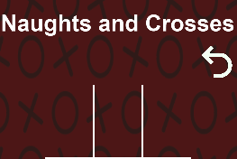
if event.phase == "began" then
--create an undo button
local undoButton = widget.newButton({

id = 'undoButton',
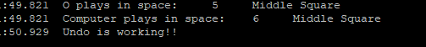
defaultFile = 'undo.png',
width = 45,
height = 45,
onPress = function()
print("Undo is working!!")
end
})
undoButton.x = d.contentCenterX + 130
undoButton.y = d.contentCenterY - 175

- For this block of time, I decided to create a win screen so instead of just printing ‘player wins’ it will actually show in the game who has won. This wasn’t the hardest thing to implement as I have done screen changes previously within the code (e.g. start screen), however I only made a screen for when the human player wins.

Xwinner = false
Owinner = false

if Winner() then
print("Player O is the Winner!!!")
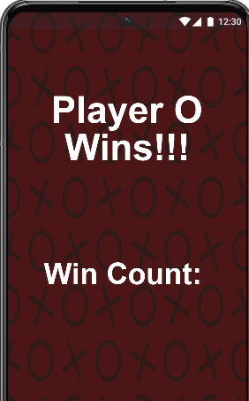
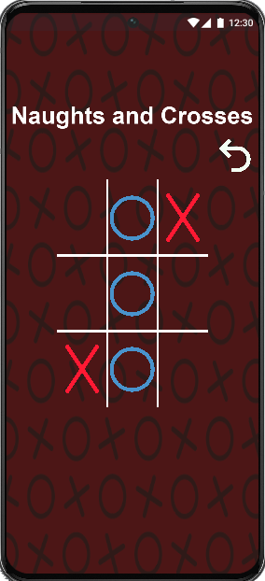
Owinner = true
else
print(“X wins”)

if Owinner then
local gameblocker = d.newRoundedRect(
d.contentCenterX,
d.contentCenterY,
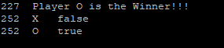
1000,
1000,
1000
)
gameblocker:setFillColor(0, 0, 0, 1)
gameblocker:toFront()
background:toFront()

local OWinText1 = d.newText({
text = "Player O",
x = d.contentCenterX,
y = screenTop + 130,
font = native.systemFontBold,
fontSize = 50
})
local OWinText2 = d.newText({
text = "Wins!!!",
x = d.contentCenterX,
y = screenTop + 180,
font = native.systemFontBold,
fontSize = 50
})
local OWinStreak = d.newText({
text = "Win Count: ",
x = d.contentCenterX,
y = screenTop + 350,
font = native.systemFontBold,
fontSize = 40
})

- This step was spent creating a reset button which doesn’t fully work yet but will reset the game entirely. This will be accompanied by a ‘review’ button in future updates.

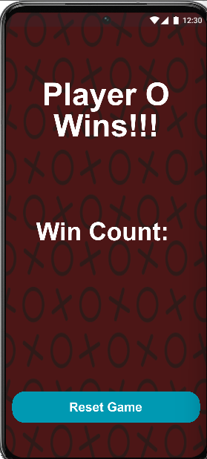
local resetrect = d.newRoundedRect (
d.contentCenterX,
d.contentCenterY + 275,
300,
50,
20
)
resetrect:setFillColor(0, 0.6, 0.7)

local resetgame = widget.newButton({
label = 'Reset Game',
id = "onPress",
x = d.contentCenterX,
y = d.contentCenterY + 275,
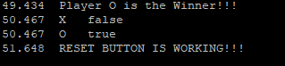
width = 278,
height = 32,
font = native.systemFontBold,
fontSize = 20,
labelColor = { default={1, 1, 1, 1}, over={1, 1, 1, 1} },
onPress = function()
print("RESET BUTTON IS WORKING!!!")
for i = 1, 9 do
board[i][7] = EMPTY

end

end
})

- My time in this block was spent creating an identical win screen for the computer winning, which wasn’t groundbreaking tech but needed to be done. As well as that I had to move all of the code I hade worked on from step 14 onwards out of the ‘NaughtsAndCrosses’ function for ease of reading and usability. This took most of the time as it was tedious and kept breaking components when I created the new function.
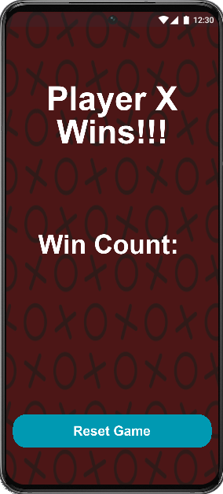
local function endScreen( event )
if Owinner then
local gameblocker = d.newRoundedRect(
d.contentCenterX,
d.contentCenterY,
1000,
1000,
1000
)
gameblocker:setFillColor(0, 0, 0, 1)
gameblocker:toFront()
background:toFront()

local OWinText1 = d.newText({
text = "Player O",
x = d.contentCenterX,
y = screenTop + 130,
font = native.systemFontBold,
fontSize = 50
})
local OWinText2 = d.newText({
text = "Wins!!!",
x = d.contentCenterX,
y = screenTop + 180,
font = native.systemFontBold,
fontSize = 50
})
local OWinStreak = d.newText({
text = "Win Count: ",
x = d.contentCenterX,
y = screenTop + 350,
font = native.systemFontBold,
fontSize = 40
})

elseif Xwinner then
local gameblocker = d.newRoundedRect(
d.contentCenterX,
d.contentCenterY,
1000,
1000,
1000
)
gameblocker:setFillColor(0, 0, 0, 1)
gameblocker:toFront()
background:toFront()

local XWinText1 = d.newText({
text = "Player X",
x = d.contentCenterX,
y = screenTop + 130,
font = native.systemFontBold,
fontSize = 50
})
local XWinText2 = d.newText({
text = "Wins!!!",
x = d.contentCenterX,
y = screenTop + 180,
font = native.systemFontBold,
fontSize = 50
})
local XWinStreak = d.newText({
text = "Win Count: ",
x = d.contentCenterX,
y = screenTop + 350,
font = native.systemFontBold,
fontSize = 40
})

end
local resetrect = d.newRoundedRect (
d.contentCenterX,
d.contentCenterY + 275,
300,
50,
20
)
resetrect:setFillColor(0, 0.6, 0.7)

local resetgame = widget.newButton({
label = 'Reset Game',
id = "onPress",
x = d.contentCenterX,
y = d.contentCenterY + 275,
width = 278,
height = 32,
font = native.systemFontBold,
fontSize = 20,
labelColor = { default={1, 1, 1, 1}, over={1, 1, 1, 1} },
onPress = function()
print("RESET BUTTON IS WORKING!!!")
for i = 1, 9 do
board[i][7] = EMPTY

end

end
})
print('X', Xwinner)
print('O', Owinner)
end

- At this point in my code I had realised the structure was non-existent and hard to keep track of. Although it is still a bit all over the place, I decided I should group together the different screens. I could have used scenes for this but I di not want to create additional files, so I stuck with just groups per screen. This was extremely finnicky and difficult to restructure the entire code without breaking different things. Regardless, I still broke a lot of the code which had to then be fixed back to the original state, hence the 2.5+ hour block. The code below is broken up into the actual lines I wrote, which is in many different places within the actual code. This was all in order to make the reset button physically work which was achieved. The images showcase some of the issues I ran into.

local startup = d.newGroup()
local game = d.newGroup()
local gameend = d.newGroup()
game.isVisible = false
gameend.isVisible = false
local function createBoard() -- I also changed the board into a
callable function
board = {{"tl", 1, w20, h40, w40, h20, 0}, {"tm", 2, w40, h40, w60, h20, 0}, {"tr", 3, w60, h40, w80, h20, 0},

{"ml", 4, w20, h60, w40, h40, 0}, {"mm", 5, w40, h60, w60, h40, 0}, {"mr", 6, w60, h60, w80, h40, 0},

{"bl", 7, w20, h80, w40, h60, 0}, {"bm", 8, w40, h80, w60, h60, 0}, {"br", 9, w60, h80, w80, h60, 0}}
end
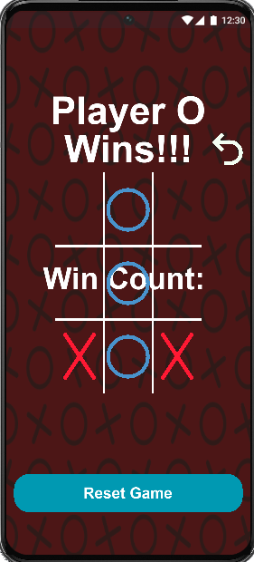
startup:insert(background)
startup:insert(titleScreen)
startup:insert(titleScreen2)
startup:insert(titleScreen3)
startup:insert(roundedRect)
startup:insert(startGame)
startup:insert(hardmode)
startup:insert(hardButton)
local function restart()

game:insert(background)
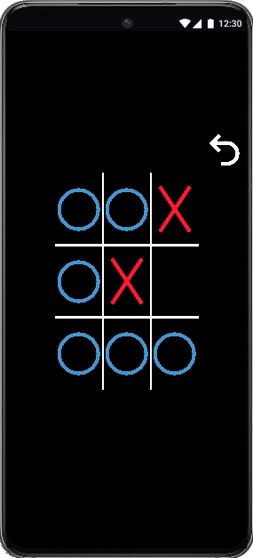
game:insert(titleScreen2)
gameend:removeSelf()
gameend = d.newGroup()
createBoard()
Runtime:addEventListener("touch", NaughtsAndCrosses)
gameend:insert(background)

background:toFront()
gameend:insert(OWinText1)
gameend:insert(OWinText2)
gameend:insert(OWinStreak)
background:toFront()

gameend:insert(background)
gameend:insert(XWinText1)
gameend:insert(XWinText2)
gameend:insert(XWinStreak)
gameend:insert(resetrect)
onPress = function()
print("reset button is working")
gameend:removeSelf()

restart()
gameend:insert(resetgame)
if #board == 0 then
createBoard()
end
startup.isVisible = false
game.isVisible = true
game:insert(background)
game:insert(titleScreen2)
game:insert(undoButton)
game:insert(lline)
game:insert(rline)
game:insert(bline)
game:insert(tline)
lline:toFront()
rline:toFront()
bline:toFront()
tline:toFront()
endScreen()
game.isVisible = false
gameend.isVisible = true

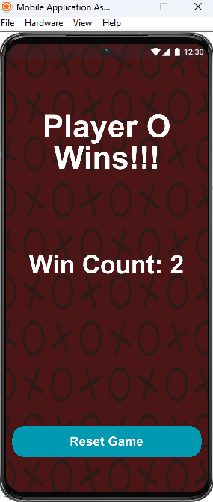
- This block of time was spent finding and fixing the errors left over from step 17, as well as completing the win count variable which wasn’t very hard, just creating an incrementing variable depending on X or O winning.
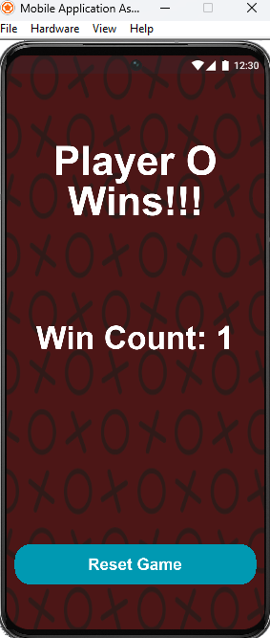
local Owincount = 0
local Xwincount = 0
local XandO = d.newGroup()
local OWinStreak = d.newText({
text = "Win Count: " .. tostring(Owincount),
x = d.contentCenterX,
y = screenTop + 350,
font = native.systemFontBold,
fontSize = 40
})
gameend:insert(OWinStreak)
local XWinStreak = d.newText({
text = "Win Count: " .. tostring(Xwincount),
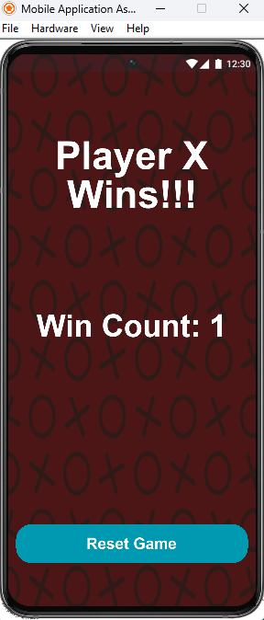
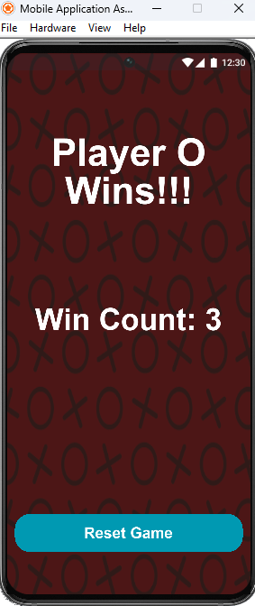
x = d.contentCenterX,
y = screenTop + 350,
font = native.systemFontBold,
fontSize = 40
})
gameend:insert(XWinStreak)
offScreen(XandO)
Owinner = true
Owincount = Owincount + 1
offScreen(XandO)
Xwinner = true
Xwincount = Xwincount + 1
endScreen()
XandO:insert(r)
print("Computer plays in space:", compChoice, bspace)
XandO:insert(r)
timer.performWithDelay(1000, function()
Xwinner = true
Xwincount = Xwincount + 1
offScreen(XandO)
game.isVisible = false
gameend.isVisible = true
endScreen()

- Creating and finishing the replay logic for when the replay button is pressed in the end screen. This was a very difficult section as every time I made a step towards finishing the function, something else in the code broke. You will see within the pictures some of the issues I ran into. Mostly switching back between groups would always result in something going wrong and a lot of time spent fixing.

local function restart()

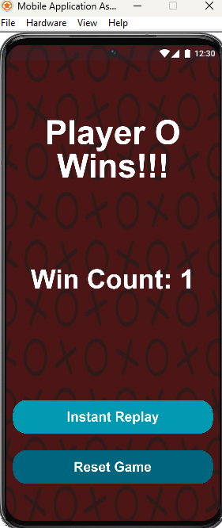
game:insert(background)
game:insert(titleScreen2)
if gameend then
gameend:removeSelf()
gameend = d.newGroup()
end
XandO:removeSelf()
XandO = d.newGroup()

for i = 1, 9 do
board[i][7] = EMPTY
end
Xwinner = false
Owinner = false
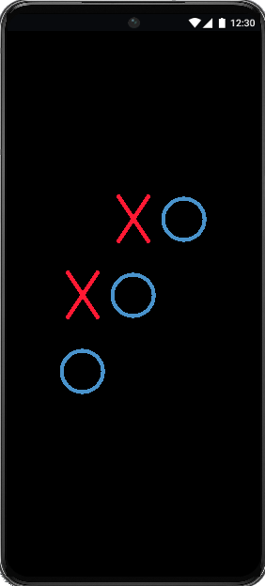
whichTurn = O
createBoard()

Runtime:addEventListener("touch", NaughtsAndCrosses)
end

local function replaylogic()
local replaytext = d.newText({
text = "Instant Replay",
x = d.contentCenterX,
y = screenTop + 160,
font = native.systemFontBold,
fontSize = 20
})
replaytext:setFillColor(1, 1, 1, 1)
for index, t in ipairs(gameplay) do
local delay = 500 * index -- Add a delay for each move
timer.performWithDelay(delay, function()
if index % 2 == 1 then
--place O for odd moves, X for even
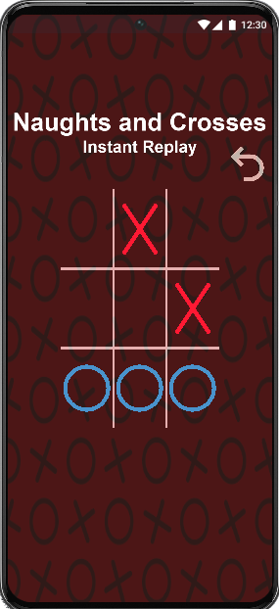
s = d.newCircle(board[t][3] + 3, board[t][6] + 20, w20 / 2.5, h20 / 2.5)
s:setFillColor(0, 0, 0, 0)
s:setStrokeColor(0.29, 0.58, 0.80)
s.strokeWidth = 5
s.anchorX = 0
s.anchorY = 0
XandO:insert(s)

print("Replay O in space:", t)
else
local centerX = (board[t][3] + board[t][5]) / 2
local centerY = (board[t][4] + board[t][6]) / 2
local size = 30

r = d.newLine(centerX - 20, centerY - size, centerX + 20, centerY + size)
r:setStrokeColor(1, 0.1, 0.2)
r.strokeWidth = 5
r.anchorX = 0
r.anchorY = 0
XandO:insert(r)
r = d.newLine(centerX - 20, centerY + size, centerX + 20, centerY - size)
r:setStrokeColor(1, 0.1, 0.2)
r.strokeWidth = 5
r.anchorX = 0
r.anchorY = 0
print("Computer plays in space:", t)
XandO:insert(r)

end
local replayrect = d.newRoundedRect (
d.contentCenterX,
d.contentCenterY + 200,
300,
50,
20
)
replayrect:setFillColor(0, 0.6, 0.7)
gameend:insert(replayrect)

local replayGame = widget.newButton ({
label = 'Instant Replay',
id = "onPress",
x = d.contentCenterX,
y = d.contentCenterY + 200,
width = 278,
height = 32,
font = native.systemFontBold,
fontSize = 20,
labelColor = { default={1, 1, 1, 1}, over={1, 1, 1, 1} },
onPress = function()
print("instant replay button working")
isReplaying = true
restart()
replaylogic()
end
})
gameend:insert(replayGame)

- This block of time was spent creating the logic for the undo button which proved a lot harder than I thought it would, and also attempting a start to the ‘done’ button that appears after the instant replay. I ran into several issues with the undo button due to the way I had set up the X and O logic. When I would undo a move for X, it would only remove on of the lines, leaving a permanent remnant of the move. The way I solved this was by forming a table and putting the X and O graphics within the table, so that they could individually be deleted in full. A large block of the time was spent attempting the ‘done’ button, however most of this was fruitless. The next section will go into more detail
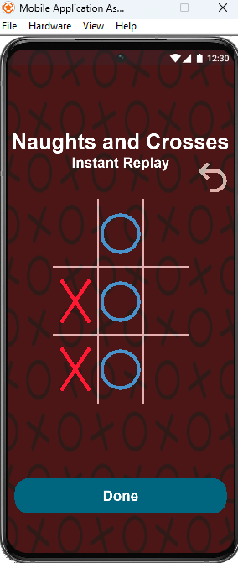
local undoButton = widget.newButton({

id = 'undoButton',
defaultFile = 'undo.png',
width = 45,
height = 45,
onPress = function()
print("Undoing last move...")
if #gameplay > 0 then
local lastMove = table.remove(gameplay)
board[lastMove][7] = EMPTY
local lastplay = table.remove(drawing)
if lastplay then
if type(lastplay) == "table" then
for _, line in ipairs(lastplay) do
d.remove(line)
end
end
end

whichTurn = whichTurn == X and O or X
end
end

})
undoButton.x = d.contentCenterX + 130
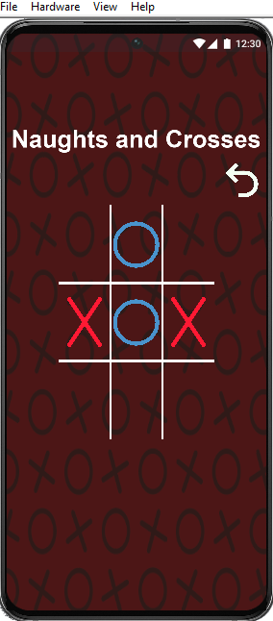
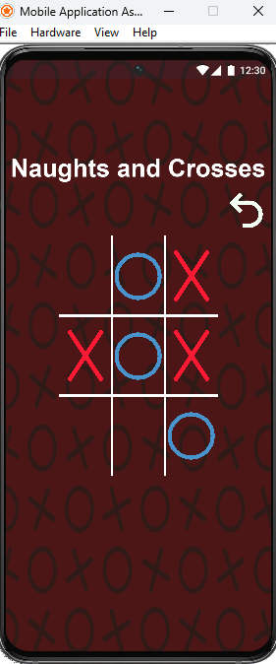
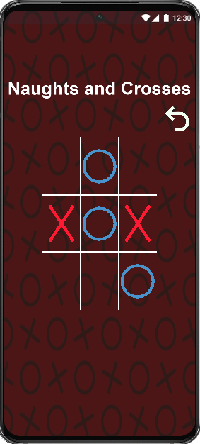
undoButton.y = d.contentCenterY - 175
game:insert(undoButton)
offScreen(titleScreen)
titleScreen2:setFillColor(1,1,1,1)
offScreen(titleScreen3)
offScreen(startGame)
offScreen(roundedRect)
offScreen(hardButton)
offScreen(hardmode)
local Done = widget.newButton({
label = 'Done',
id = "onPress",
x = d.contentCenterX,
y = d.contentCenterY + 275,
width = 278,
height = 32,
font = native.systemFontBold,
fontSize = 20,
labelColor = { default={1, 1, 1, 1}, over={1, 1, 1, 1} },
onPress = function()
offScreen(replaytext)
end
})

- Instead of fixing the logic for the done button, I decided I needed to create the logic for if there is no winner (drawn game). This did not prove too difficult, most of the time was spent trying to change to the gameend screen whilst keeping the game board visible.
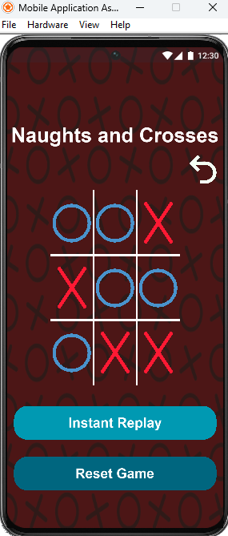
local function filledBoard()
for i = 1, 9 do
if board[i][7] == EMPTY then
return false
end
end
return true
end

if filledBoard() then
print("game ends in a draw")
endScreen()
end
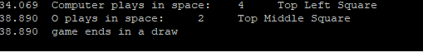

- Finally, the done button logic had to be done. A lot of the time was spent on dumb mistakes, which were solved with 2 lines of code (inserting the done logic into groups). It took about 30 minutes to work that one out… however the done button now works and sends the user into another game.

--if the replay is over (#gameplay (table length has been run through) expended)
if index == #gameplay then
Runtime:addEventListener("touch", NaughtsAndCrosses)
local done1 = d.newRoundedRect(
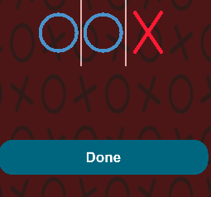
d.contentCenterX,
d.contentCenterY + 275,
300,
50,
20
)
done1:setFillColor(0, 0.4, 0.5)
local Done = widget.newButton({
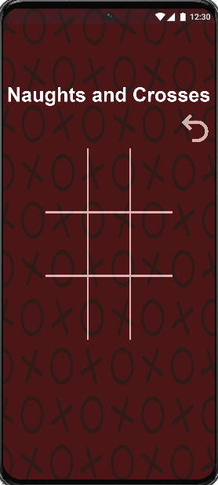
label = 'Done',
id = "onPress",
x = d.contentCenterX,
y = d.contentCenterY + 275,
width = 278,
height = 32,
font = native.systemFontBold,
fontSize = 20,
labelColor = { default={1, 1, 1, 1}, over={1, 1, 1, 1} },
onPress = function()
offScreen(replaytext)
gameend:insert(background)
XandO.isVisible = false
gameend.isVisible = true
isReplaying = false
gameend:removeSelf()
gameplay = {}
restart()

end

})

gameend:insert(done1)
gameend:insert(Done)

end

- The code is functionally completed in my eyes, and all that was left was to walk myself back through my code and add comments here and there to describe basically what was going on within the section

TOTAL LINES OF CODE AT SUBMISSION POINT: 611

